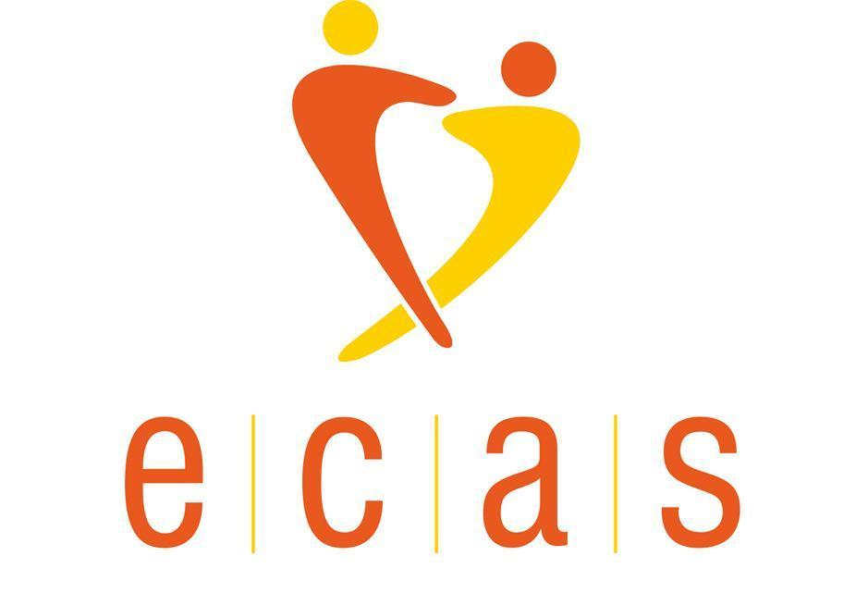
Lifeguard Job Description and Application Process

Responsible to: Ecas Swimming Group Leader
Hours: 2.5 hours per week. Wednesday - 6.30pm to 8.50pm
Salary: £15.00 per hour
Start Date: As soon as possible.
Contract: Permanent

About us
Ecas is an Edinburgh based charity and was established over a hundred years ago. The charity works to improve the quality of life of physically disabled people in the Edinburgh and Lothians area: promoting equality, choice and participation through our activities, befriending service and grants. Provision of activities for physically disabled adults is one of Ecas’ core aims. Groups are likely to be of mixed ability and to have varied physical disabilities.

Role overview
Hydrotherapy sessions provide our service users the opportunity to improve their strength, coordination, and confidence in a warm water environment.

Ecas is seeking a lifeguard for the hydrotherapy swimming classes on Wednesdays at the Hydropool, Oaklands School in the Pennywell/Drylaw area.

Purpose of Job
Providing lifeguard services during Ecas swimming classes under the direction of the Swimming Group Leader.

To assist the Group Leader in organising and running swimming classes for people with a physical disability.

Ensuring that Ecas’ duty of care to service users is discharged.

Encouraging class members to take part in the class activities and to become more independent in their outlook.

Major Tasks/Job Activities
To be the lifeguard for Ecas swimming classes, working under the direction of the Swimming Group Leader.

To undertake tasks as required by the Swimming Group Leader to aid the smooth running of the classes.

To comply with the Ecas Health and Safety Manual and to follow the procedures required by the risk assessments.

To assist the Group Leader to prepare fully for each class (materials, room layout etc) and ensure that materials are tidied away neatly.

To attend induction, other training, and meetings as deemed necessary by Ecas.

Service users requiring intimate care
The Ecas class application form currently states that Ecas does not provide personal care and cannot take responsibility for anyone requiring medical or toileting assistance. There are good reasons for this, not the least of which is that Ecas staff are neither trained nor insured to provide such care.
The provision of care is something that Ecas is researching but is not something that we are currently able to provide ourselves (but see below – as we can provide funding for it in some circumstances). Ecas staff and volunteers are therefore not to provide such care, and Group Leaders must brief volunteers accordingly.

In general, the dividing line is that you may assist a service user to reach the toilet door, but must not go in. Similarly, staff are not to help service users to transfer between wheelchairs and chairs because to do so requires you to bear the weight of the service user on you. Therefore service users who require greater assistance than that outlined above must bring their own carer. This is best achieved by the Group Leader having a word with the Chief Executive or Administrator following which a meeting with the service user concerned will be arranged.

Ecas appreciates that not all service users can afford carers and can provide some basic advice to help – including referring service users to our own grants fund which the Board of Directors have agreed, can provide financial help for carers to allow a service user to continue to come to our classes. This may include care whilst travelling to and from classes.

Responsibility for staff and volunteers
All group leaders are responsible for any volunteers who assist them, and they are to follow the procedures particularly the volunteers policy; group leaders fulfil the role of volunteer manager as described in the volunteer policy. The lifeguard may be required to assist the Group Leader in this.

Decisions made in course of job
The principle decisions reflect the need to ensure the health and safety of service users.

Supervision received
The lifeguard will work under the supervision of the Group Leader.

Educational/vocational qualifications required
The lifeguard must provide appropriate evidence of an in-date suitable qualification, e.g. a National Pool Lifeguard Qualification (NPLQ), and remain in-date. An enhanced disclosure will be required.

Application process
To apply please send your C.V. with the names of two referees. Please also send a covering letter (preferably 1 side, but maximum 2 sides, of A4 with minimum 11 font) clarifying how you meet the required skills and experience, and saying why you consider yourself suitable for the post. Referees will not be contacted until an offer has been made and accepted.

Completing the Equal Opportunities Monitoring Form is entirely voluntary and will be used for analysis purposes only. The information supplied will be kept confidential and will not be forwarded to the recruitment panel.

We value diversity, promote equality and encourage applications from people of all backgrounds.

We invite applications as soon as possible ahead of interviews at Ecas’ office in Norton Park.

Applications should be sent FAO: Ally Irvine, Chief Executive.
Email: hello@ecas.scot

If you would like to discuss the opportunity, please contact Liz Jarvis, Administrator or Ally Irvine, Chief Executive. Tel: 07500 221 618/0131 475 2344. Email: hello@ecas.scot

Website: https://www.ecas.scot/ Registered Charity No. SC014929

